1. Add Bootstrap to the site.
2. Style the site navigation so that you are using either tabs or pills.
3. Use a jumbotron or page header to call out big news - your restaurant is opening a new location!
4. Make the site responsive using Bootstrap's grid system.
   * The menu items should stack well, with no overlapping.
   * The front page content should stack as well.
   * Change the *Home*link to use an Icon from one of the supported fonts that looks like a house.
5. Add a Carousel that rotates with three pieces of information:
   * We're opening a new location!
   * We're rolling out our seasonal menu, with special options for this season.
   * The Drink of the Month is SG Special Brew.
6. Use the Bootstrap form items for your Contact Us form, validate in Javascript that data has been provided and give a message that the information is valid without submitting it anywhere.
7. Make sure that users who have JavaScript disabled know that this site is best viewed with JavaScript enabled.

Requirements

1. Your header and footer must match across the pages, so store their styles in an external file called **restaurantStyles.css**.
2. Apply all positioning CSS styles for the image on the home page as an inline style.
3. Apply all styles for the menu and contact form in internal style sheets.
4. Style the restaurant name with a hosted or embedded font.
5. Make sure that the menu item names are larger than their descriptions.
6. Give the menu background a color other than white.
7. Set the background of the home page's content - not including the header, footer, or site navigation - to a color other than white.
8. Set the form labels for the required fields to be bold.
9. Style the site navigation so that:
   * Visited links appear in a different color than their default state.
   * When you hover over a link, the text is bold. This should only be when hovering. Otherwise, the text should be the normal thickness.
   * Active links should not be underlined.
10. Add a section to the menu for beverages, with a table like the one below.
11. Style this table to match your site's look and feel.

|  |  |
| --- | --- |
| **Beverages** | |
| Root Beer | $3.00 |
| Bottled Water | $1.25 |
| Lemonade | $1.00 |
| Iced Tea | $1.25 |

In this assessment, you will create a small three-page website for a restaurant. You are required to implement the site according to the wireframes found below.

#### You will do a code review of the full Restaurant Site in class during the first week so make certain you've saved this to your repository when you're done.

## Requirements

1. The site and pages must be laid out to match the wireframes below.   
   (**Note: The elements do not need to be centered but there does need to be a logical and cohesive arrangement of the required information in each wireframe on your pages.)**
2. You must create a name for the restaurant.
3. You must supply a fictional address and phone number for the restaurant.
4. You must supply a picture for the restaurant home page.
5. You must supply a description of the restaurant.

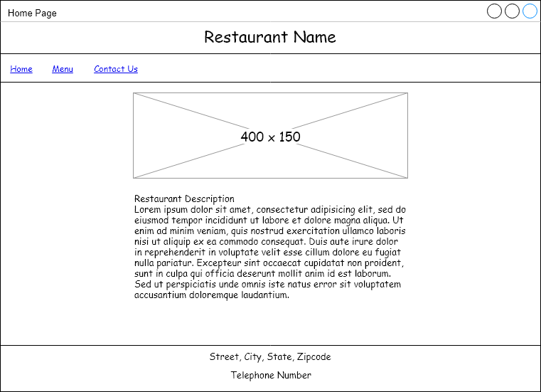Restaurant site home page wireframe

[Skip long description of home page](https://lms.thesoftwareguild.com/courses/175/pages/code-assessment-restaurant-site-part-1?module_item_id=18070#endhomepage)

Wireframe includes the following content, from top to bottom:

* Main title: Restaurant Name
* Horizontal rule
* Hyperlinks labeled Home, Menu, and Contact Us in a single row
* Horizontal rule
* An image measuring 400 x 150
* A text block that starts with Restaurant Description
* Horizontal rule
* Street, City, State, Zipcode (on a single row of text)
* Telephone Number

End long description of home page

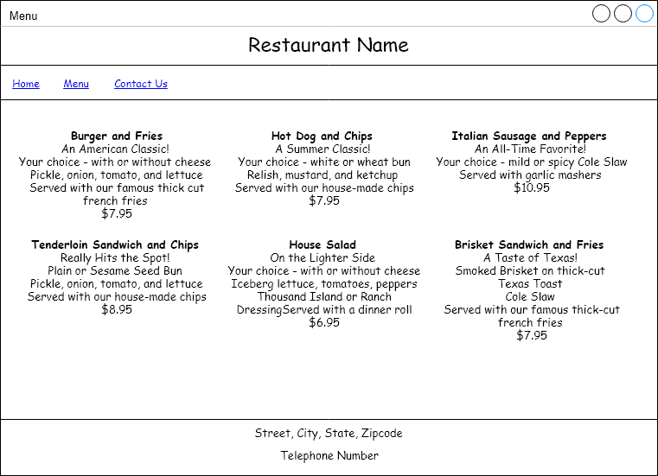Restaurant site menu page wireframe

[Skip long description of menu page](https://lms.thesoftwareguild.com/courses/175/pages/code-assessment-restaurant-site-part-1?module_item_id=18070#endmenupage)

Wireframe includes the following content, from top to bottom:

* Main title: Restaurant Name
* Horizontal rule
* Hyperlinks labeled Home, Menu, and Contact Us in a single row
* Horizontal rule
* A menu laid out in a grid with three columns and two rows. Each menu item is in a separate cell of the grid. The menu items on the top row include: (The / character indicates a new line of text within the cell)
  + Burger and Fries / An American Classic! / Your choice - with or without cheese / Pickle, onion, tomato, and lettuce / Served with our famous thick cut / french fries / $7.95
  + Hot Dog and Chips / A Summer Classic! / Your choice - white or wheat bun / Relish, mustard, and ketchup / Served with our house-made chips / $7.95
  + Italian Sausage and Peppers / An All-Time Favorite! / Your choice - mild or spicy / Cole Slaw / Served with garlic mashers / $10.95
* The menu items in the second row include:
  + Tenderloin Sandwich and Chips / Really Hits the Spot! / Plain or Sesame Seed Bun / Pickle, onion, tomato, and lettuce / Served with our house-made chips / $8.95
  + House Salad / On the Lighter Side / Your choice - with or without cheese / Iceberg lettuce, tomatoes, peppers / Thousand Island or Ranch Dressing / Served with a dinner roll / $6.95
  + Brisket Sandwich and Fries / A Taste of Texas! / Smoked Brisket on thick-cut Texas Toast / Cole Slaw / Served with our famous thick-cut / french fries / $7.95
* Horizontal rule
* Street, City, State, Zipcode (on a single row of text)
* Telephone Number

End long description

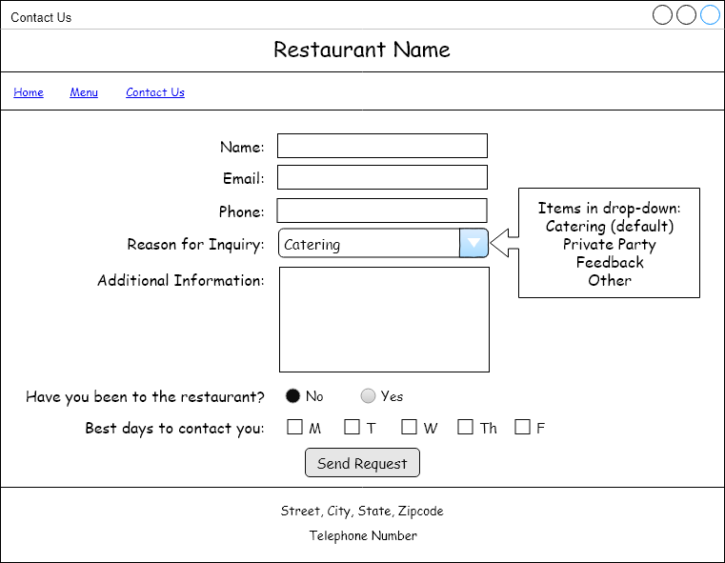Restaurant site contact us page wireframe